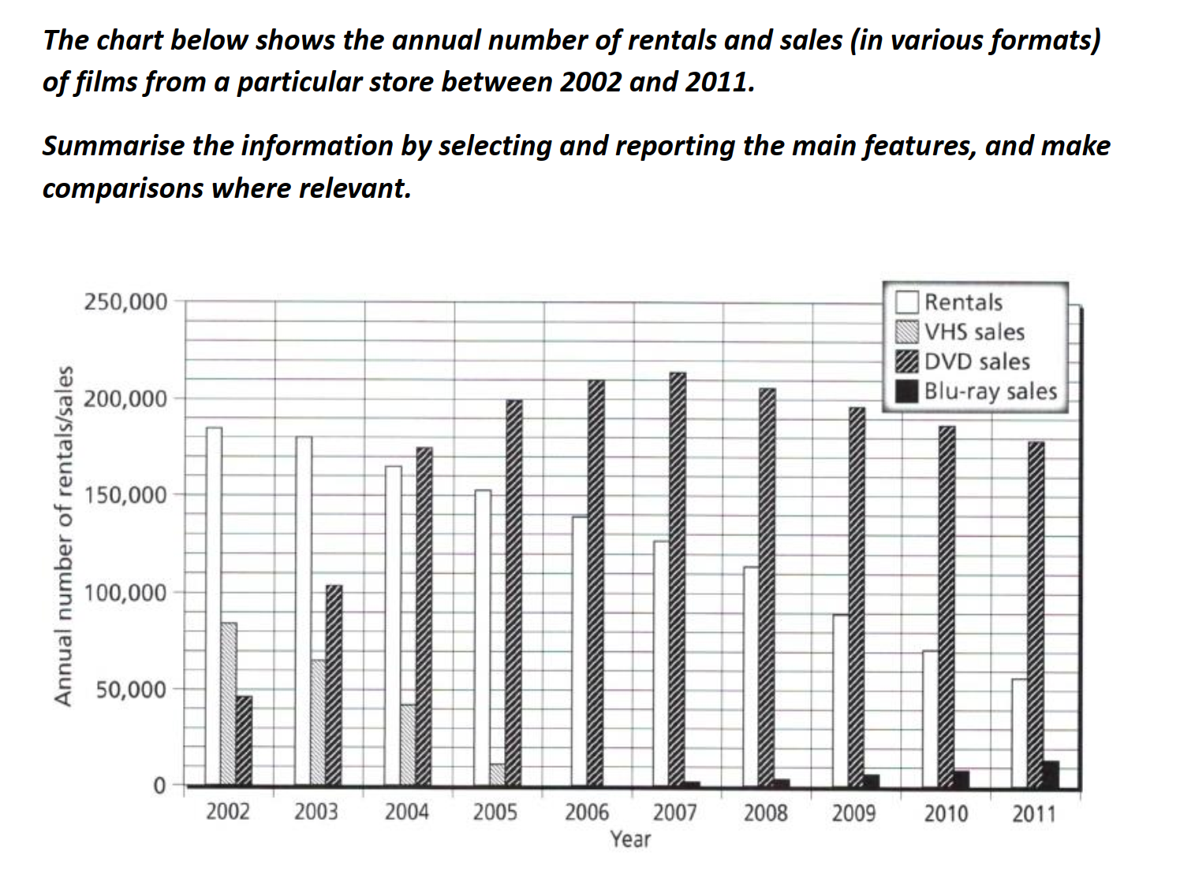
审题要领（Task focus）
- 题目描述了一个音像店，除了租金以外，销量方面进行比较的内容包括：录影带(VHS)、数字光盘(DVD)和蓝光影碟(Blu-ray)。
- 横坐标给出时间，可对相同类别的柱子顶端连线，转化为四条曲线图。
写作思路（Thinking before writing）
- Rentals呈逐年下降趋势
- DVD 销量整体最高，从 2002 年开始上升，到 2007 年到达顶峰，然后逐年递减
- VHS 逐年下降且到 2006 年以后就没有销量了
- Blu-ray 从 2007年开始销售同时其销量逐年递增
The bar chart illustrates the annual figures for rentals and sales of different formats of films in a specific store from 2002 to 2011.
The bar chart shows how the number of renting and selling 3 kinds of films changed from 2002 to 2011.

Overall, throughout this period, DVDs saw the most dramatic growth in sales and were generally the dominant products. The numbers of Blu-ray discs sold from this store increased, while those of rentals and VHS films declined.

分段依据：先主后次，第一个主体段写显著的大小/变化
BP1 : 数量大的Rentals和DVD分为一段，有交点。
BP2：数量少的VHS和Blu-ray分为一段，过程中有起点/终点。

In 2002, only 45,000 DVDs were sold, but the sales surged to 175,000 in 2004, overtaking rentals, which declined gradually from 18,500 to 16,500 during these three years. From 2004 onwards, DVD sales rose steadily to the peak at 215,000 in 2007, before falling slightly to around 180,000 at the end of the period. In contrast, there was a substantial fall in rentals, decreasing to about 55,000 by 2011.

The sales of the other two formats of films were much lower. In 2002, 85,000 VHS tapes were sold, which decreased continuously over the next three years. By 2006, this shop no longer sold these products but started to sell Blu-ray discs from 2007, and the sales grew slowly to nearly 15,000 in 2011.

